**Change a site's title, description, logo**

Once you've created a site in SharePoint SharePoint Server, you can make changes to the site's settings, such as the name, logo, description, privacy level, and site classification, as well as service limits and permissions for the site.

As owner, or user with full control permissions, you can change title, description, and logo for your SharePoint Server site..

1. Go to your site.
2. In the top right corner, select**Settings** Settings icon, or in top left, select**Site Actions** Button image.
3. Select**Site Settings**.

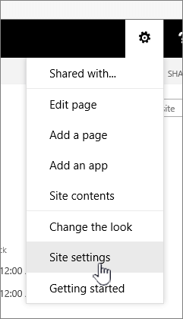

1. Under **Look and Feel**, select**Title, description, and logo**. 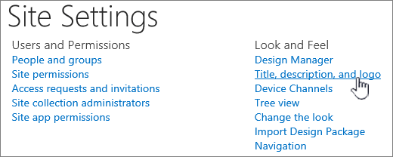
2. Update the **Title** field. Add or edit the optional **Description** for the site.

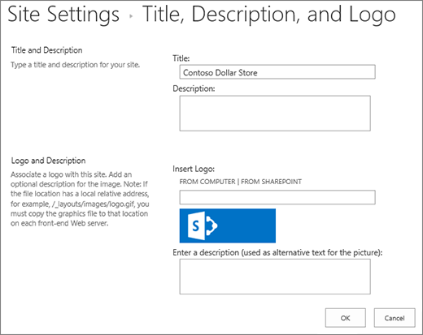

1. **For SharePoint 2016 or 2013**, under **Logo and Description**, do one of these:

Select **FROM COMPUTER**, browse for an image and selectOpen.

Select **FROM SHAREPOINT**, browse for an image on the SharePoint site, and select**Insert**.

**For SharePoint 2010**, under Logo and Description, insert a URL to an image to use as logo.

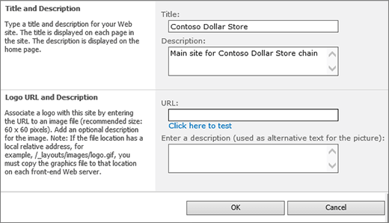

1. Fill in an optional description or Alt text. Select **OK** to save